Yogesh Sivakumar

24150029@studentmail.ul.ie

**EC6062: Applied Econometrics for Business**

**Assignment 1: Econometric Data Analysis**

1. **Objective**

The objective of this analysis is to help client firms learn how investing in employee training and capital equipment can influence their profitability. As a Business Analyst employed by a consulting firm, this project addresses client questions about whether more investment in employee training increases profits and whether replacing outdated equipment also improves firm performance. From data of 962 manufacturing, services, and ICT companies, this report explores the relationship between profitability and these the investment categories. The implementaion is done with R programming following an econometric approach.

1. **Data and Empirical Approach**

The dataset used for this analysis is a random sample of 962 manufacturing, services, and ICT firms. It gives information on firm characteristics, investments, and performance outcome results. Key variables include firms' profits (log_Profits), employee training investments (log_training), and equipment investments (log_equipment), all in natural logs. Other firm characteristics available are Enterprise_Group (whether the firm is part of a group), Firm_Age (number of years since registration), and Export_yes_no (whether the firm exports).

Firm size is captured by Small_Firm (whether a firm has fewer than 50 employees) and Employees_log (log of the employees). Innovation activity is captured through innovation_yes, and R&D investment through R_D_yes. The industrial sector variable divides the firms into Manufacturing (1), Services (2), or ICT (3).

***Descriptive statistics Table***

|  |  |  |  |  |  |
| --- | --- | --- | --- | --- | --- |
| **Variable** | **Mean** | **Standard Deviation** | **Median** | **Min** | **Max** |
| **Log Profits** | 12.213 | 2.14 | 11.838 | 6.063 | 19.481 |
| **Log Training** | 0.238722 | 4.58 | 0.000857 | 0 | 13.256 |
| **Log Equipment** | 8.089 | 9.77 | 0 | 0 | 26.873 |
| **Small Firm** | 0.6694 | 17.39 | 1 | 0 | 1 |
| **Firm Age** | 23.56 | 1.71 | 20 | 1 | 125 |

As an initial exploratory step, scatterplots were developed to illustrate the relationship between firm profits and investment. The profits vs. training investment scatterplot indicates a positive correlation: those firms that had higher training expenditure had higher profits. A number of firms expended little or none, but those that expended any amount had the trendline showing a moderately strong positive correlation.

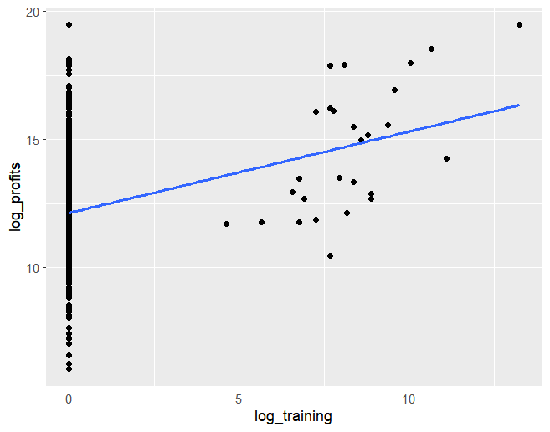

The scatterplot between profit and equipment investment also showed a positive relationship, but comparatively weaker. Those businesses that invested more in equipment had greater profits, but the outcomes were more scattered, suggesting more variability in the success of equipment investments.

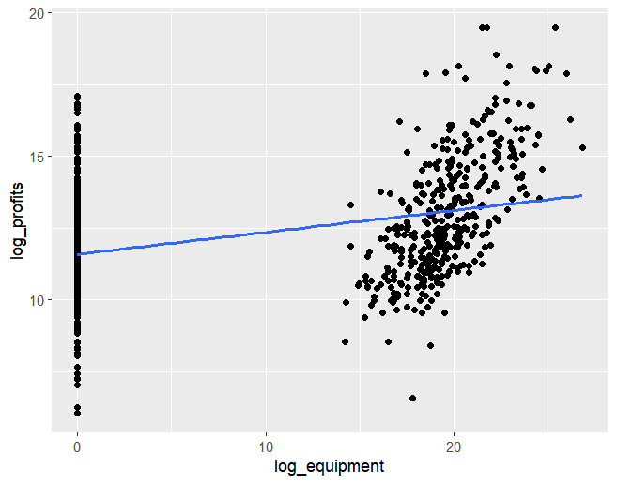

The formula implemented to carry out the analysis is:

𝑃𝑟𝑜𝑓𝑖𝑡𝑠𝑖,𝑡 = 𝛼𝑖 + 𝛃1Training𝑖,𝑡−1 + 𝛃2Equipment𝑖,𝑡−1+ 𝛃𝑋𝐗′𝑖,𝑡−1 + 𝑢𝑖,𝑡

The analysis first estimated individual simple regressions of profits on training and profits on equipment. It then moved to a multiple regression with both training and equipment. A full model was estimated by adding other control variables. Finally, the full model was then estimated separately for small and large firms in order to understand differences by firm size.

1. **Main Results**

The regression analysis tested the effect of training and equipment investment on firm profitability using a number of models of growing complexity.

|  |  |  |  |  |  |  |
| --- | --- | --- | --- | --- | --- | --- |
| **Regression Results with Robust Standard Errors** | | | | | | |
|  | | | | | | |
| Dependent variable: Log(Profits) | | | | | | |
|  |  | | | | | |
|  | Training Only | Equipment Only | Training + Equipment | Full Model | Small Firms | Large Firms |
| log_training | 0.318*** |  | 0.239*** | 0.100*** | 0.151** | 0.074* |
| log_equipment |  | 0.076*** | 0.070*** | 0.017*** | 0.009 | 0.024*** |
| Firm_Age |  |  |  | 0.014*** | 0.008** | 0.017*** |
| Employees_log |  |  |  | 0.000 | 0.000* | -0.000 |
| Export_yes_no |  |  |  | 1.596*** | 1.401*** | 1.621*** |
| Enterprise_Group |  |  |  | 0.461*** | 0.578*** | 0.437*** |
| Small_Firm |  |  |  | -2.360*** |  |  |
| innovation_yes |  |  |  | 0.524*** | 0.644*** | 0.249 |
| R_D_yes |  |  |  | -0.175 | -0.018 | -0.330* |
| Industrial_sector |  |  |  | 0.124** | 0.239*** | -0.137 |
| Constant | 12.137*** | 11.598*** | 11.586*** | 12.561*** | 10.058*** | 13.117*** |
| Observations | 962 | 962 | 962 | 962 | 644 | 318 |
| R2 | 0.049 | 0.134 | 0.160 | 0.619 | 0.189 | 0.356 |
| Adjusted R2 | 0.048 | 0.133 | 0.159 | 0.615 | 0.178 | 0.337 |
| Residual Std. Error | 1.982 (df = 960) | 1.891 (df = 960) | 1.863 (df = 959) | 1.260 (df = 951) | 1.210 (df = 634) | 1.328 (df = 308) |
| F Statistic | 48.956*** (df = 1; 960) | 148.011*** (df = 1; 960) | 91.569*** (df = 2; 959) | 154.459*** (df = 10; 951) | 16.466*** (df = 9; 634) | 18.920*** (df = 9; 308) |
|  | | | | | | |

In the first model, with profits regressed on training investment only, the log_training coefficient is estimated at 0.318, which shows a high positive correlation. This means that a 1% increase in training investment is associated with a 0.318% increase in profits. However, the model explains a very small fraction of the variation in profits, with an adjusted R-squared of approximately 4.75%, which implies other variables apart from training are important.

In the second model, in which equipment investment by itself is employed, the coefficient on log_equipment is 0.076 and is significant and positive. A 1% increase in equipment investment means a 0.076% increase in profits. The adjusted R-squared rises to about 13.27%, meaning that equipment investment explains more of the variation in profits than training does alone, but there still remains a lot of variation unexplained.

Both training and equipment investment are entered simultaneously, yet both remain positively correlated to profitability. Training is 0.239, and equipment 0.070, both independently contributing to profits. The adjusted R-squared rises slightly to about 15.86%, which implies that having both investments simultaneously explains the variation in profit better than single-variable models.

Expanding the model to include firm-specific variables—firm age, employee size, export status, innovation activity, R&D activity, and sector affiliation—provides a much more complete view of the determinants of firm profitability. In order to properly capture sector differences, the Industrial_sector variable remained as a categorical factor, thereby allowing the model to estimate different effects for manufacturing, services, and ICT companies rather than incorrectly retaining sector codes as continuous numerical values. In this full model, training investment continues to have a positive effect, with a coefficient of 0.0998, and equipment investment continues to have a positive effect, with a coefficient of 0.01679. Adjusted R-squared increases sharply to 61.49%, suggesting that the model accounts for a substantial amount of variance in the profits of firms. The other firm characteristics also have strong associations with profitability: firm age and export status have positive relationships with profits, while small firm status has an association with significantly lower profits. Innovation activity contributes to profitability, but R&D investment does not have any significant effect. These results inform us that investment in training and equipment remains important after adjusting for a broad set of firm-level covariates.

In terms of model performance, there is a clear improvement as more relevant firm characteristics are included. While the simple models have minimal explanatory power for the variation in profits, the full model has a high fit, with over 60% of the variation explained. This suggests that the full model constitutes a valuable framework for the analysis of firm profitability.

While the full model explains a large percentage of the variation in firm profit, there can still be some important variables excluded. One such variable that might have improved the analysis is reliance on external finance. Firms that are highly reliant on external finance, say loans, might have limitations that limit the size or timing of their investments which weakens the training and equipment investment profitability relationship. Including a measure of external reliance on financing could have been a wiser approach to understanding the influence of financial structures on investment success, especially in comparing small and large firms.

By examining the results for small and large companies separately reveals that there are major differences. For small companies, training investment is most important, with a coefficient of 0.146, while equipment investment is not significant. This shows that for small companies, developing employees' skills is more crucial to profitability than purchasing new equipment. In contrast, for large firms, equipment investment is larger, with a coefficient of 0.025, while training investment has a smaller and less accurate impact estimated at 0.072. The model's fit is also larger for large firms, with an adjusted R-squared of approximately 33.7%, compared to 18.2% for small firms. These findings have the implication that investment policy will have to differ by firm size: small firms would benefit most from an investment in human capital, and large firms have to invest more in capital equipment upgrades to sustain profitability.

To validate the regression results, heteroskedasticity was examined by a Residuals vs Fitted Values plot and the Breusch-Pagan (BP) test. The plot showed visual patterns of non-constant variance versus fitted values. The BP test also identified heteroskedasticity with a test statistic of approximately 37.74 and p-value less than 0.001, thereby rejecting the null hypothesis. To adjust for this issue, robust standard errors were employed in all model estimations. This adjustment ensures that statistical inference for the coefficients' significance is valid even in the presence of heteroskedasticity of the error terms.

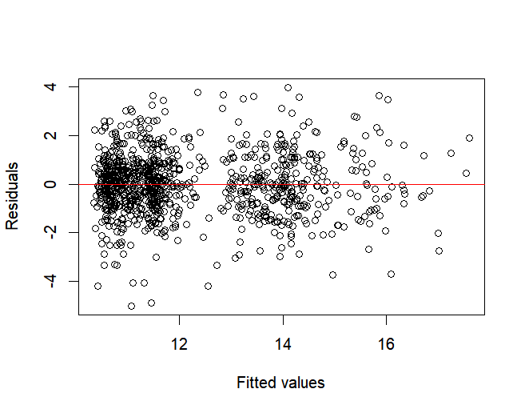

1. **Conclusion**

This research examined the correlation between employee training and equipment investments by companies and their implications on profitability. The results show consistently that both training and equipment investments are positively associated with company profits. The relative importance of each of these investments differs, however, across company types.

For small firms, investment in training appears particularly effective. The evidence indicates that training investments have a positive impact on profitability for smaller firms, likely because human capital development directly improves operating efficiency. For larger firms, however, equipment investment is more highly associated with profitability growth which reflects the importance of equipment upgrades, technology, and scale efficiencies in larger firms.

Based on these findings, client companies are recommended to invest and take into account the company's size. Small companies should focus investing in the upgradation of workers to enhance workers' capabilities, whereas large companies should focus extra attention on upgradation and expansion of equipment base. Nevertheless, any company can benefit through synchronizing both investment types based on its needs in operation as well as based on growth targets.

Although the analysis provides useful insights, it is not without some limitations. One important limitation is the limited sector control. Although industrial sector dummies were controlled for in the regressions, they might not adequately capture significant sector-specific dynamics, e.g., differences in competition intensity, rates of technological adoption, or regulatory regimes. These uncontrolled sectoral controls have the potential to influence both the investment trends as well as profitability outcomes and thus potentially on the validity of the estimated effects. Future works can improve it by employing finer industry-specific controls or interaction variables to better adjust in respect to sectors.

Lastly, investments in training and equipment are crucial determinants of the profitability of firms, but their performance is determined by firm-specific and industry-specific characteristics. An investment strategy that is tailored, combined with the right attention to industry dynamics, is crucial to maximizing returns and achieving sustainable growth.